Contemplative Service:
January 7th @ 6:30pm
As iron sharpens iron,
so one person sharpens a friend.
— Proverbs 27:17
Dave Tillman

The next Contemplative Service will be January 7th at 7:00pm at the church. This is a quiet, reflective service with simple-repetitive music, reflective readings, and times of silence. The style is very different than our normal Sunday morning worship service.

Church Office Hours
Dave Tillman
The core office hours for Emily Roering (our new Administrative Assistant) are Thursdays and Fridays, 11:00am to 4:00pm. She works about fifteen hours a week, but these are the hours she is committed to being in the office.
Pastor Dan is changing his work schedule to be Tuesdays through Fridays to more closely overlap with Emily. His schedule is flexible as he is often away from church for visitation, meetings, and other conflicts. If you want to meet with him, please make an appointment.

Dates to Save:

- Feb. 1 – Annual Congregational Meeting
- Mar. 22-28 – Mission Trip to Spruce Pine, North Carolina

Men’s Retreat:
Boys and Men Are in Crisis!
January 23-25, 2026
Dave Tillman
The description for Scott Galloway’s book Notes on Being a Man (Simon & Schuster, 2025) reads:
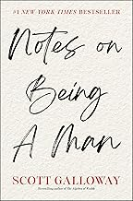
Boys and men are in crisis. Rarely has a cohort fallen further and faster than young men living in Western democracies. Boys are less likely to graduate from high school or college than girls. One in seven men reports having no friends, and men account for three of every four deaths of despair in America. Even worse, the lack of attention to these problems has created a vacuum filled by voices espousing misogyny, the demonization of others, and a toxic vision of masculinity. But this is not just a male issue: Women and children can’t flourish if men aren’t doing well. And as we know from spates of violence, there is nothing more dangerous than a lonely, broke young man.”
This is the topic of discussion for this year’s Men’s Retreat. Pastor Dan will be leading. It will be helpful for participants to read this book beforehand. It is available on Amazon in Hardcover, Kindle, Audiobook, and Audio CD.
The logistics of the retreat will be as in years past. We will carpool up to Clearwater Forest Campground and Retreat Center on Friday, January 23rd, and return Sunday afternoon, January 25th. We will again be staying in Eagle Lodge. The cost will again be $175. This covers food, lodging, and supplies.

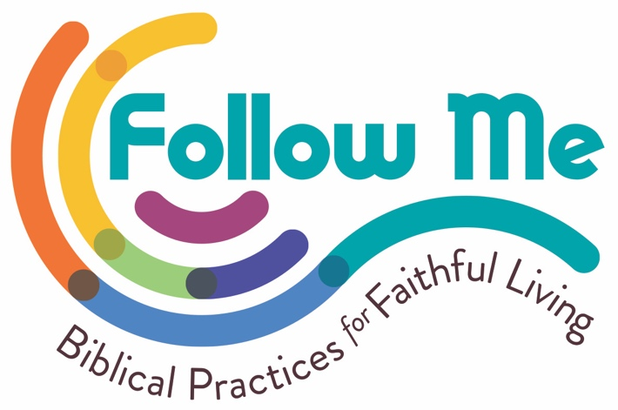
Baptism:
Symbol and Sacrament
Symbols are great teachers because they can be packed with a whole range of meanings. Meanings that can even grow and change over time as more and more people continue to use that symbol.
Baptism is a great illustration of this. From what we know, it started with John the Baptist (hence the name), who intended it to represent forgiveness of sin and a change of heart and life (Mark 1:4). The Apostle Paul would pick up on this idea and expand upon it referring to this process as gaining a new life or identity in Christ—even using the language of participating in Christ’s death and resurrection before our biological death.
“Therefore, we were buried together with him through baptism into his death, so that just as Christ was raised from the dead through the glory of the Father, we too can walk in newness of life.” (Romans 6:4, CEB)
The early church also would come to understand baptism as a time of welcoming people into the faith and even into a specific group of believers, creating a newly defined family (think Paul’s Body of Christ, 1 Corinthians 12, and his frequently used, “Siblings in Christ”). Theologically, this idea even got expanded to the point where we understand the words spoken to Jesus by God at his baptism to also apply to us—that we too are God’s beloved children (Mark 1:11).
From that same story of Christ’s baptism, Christians also adopted the idea that this symbol imbues the Holy Spirit. Just as the Spirit descended on Jesus in the form of a dove, we also recognize at baptism that the Holy Spirit is a gift being given to us. A recognition of Jesus’ promise to his disciples that they would receive the Holy Spirit (John 14:16 & 20:22).
In summary, baptism started as an act to remind us of God’s forgiveness and call to change our hearts and lives. But understanding of this simple but powerful act grew to include establishing a new identity, a death and resurrection, a belonging to a new group/family, a reminder that we are beloved children of God, and even gifted with the Holy Spirit.
As you probably know, churches and people have thought differently about when it is most appropriate for someone to be baptized. The two most common are when someone is an infant or when they make a public affirmation of their faith (either as a youth or adult). However, if you come down on this, it probably means that you or your tradition is either emphasizing one of these meanings over another. Or, at the very least, understanding them slightly differently. For example, an adult baptism might more strongly emphasize a person’s need for forgiveness and desire to live a new life, whereas an infant baptism might emphasize the belovedness of every person as a child of God. But infant baptism can also be about forgiveness and a call to a new life. It will just take on the nuanced meaning of God’s general forgiveness for all humanity and the gift of the Holy Spirit that beckons each of us to live in a better way. It doesn’t make one way right. It is just further evidence of how rich and meaningful this symbol is.
One more thing.
So far, I’ve been talking about the symbolism of baptism. But in our tradition, and really for nearly all Christians, baptism is more than a symbol. It is a sacrament. When we call something that, what we mean is that it is a sacred act. It is an act that doesn’t just mean something; it actually does something. Traditions will vary here, but how I have come to understand this can probably best be understood in an example.
To get married, you could just go to the courthouse, sign a document, and be married. You don’t have to have a service with a minister, a white dress, play the wedding march, exchange rings, kiss in front of everyone, or throw a party. Doing so doesn’t make you married. But it also isn’t nothing either.
Likewise, having a service with a minister, who pours water on your head, and says a prayer thanking God for you and all the things God does, doesn’t actually forgive your sins, allow you to live a new life, welcome you into the group, claim you as God’s child, or give you the Holy Spirit. The water isn’t magic after all. But the act doesn’t do nothing either.
Sometimes we need those sacred acts full of rich symbolism. Not only to express a whole range of ideas and varying shades of those ideas, but also so we have a moment where it all becomes real—like exchanging in front of our loved ones makes the marriage real. So too does pouring ordinary water over our heads make, well, a whole host of ideas a reality.
I look forward to exploring more about what Baptism means to all of us this month.
Be well and do good,
Pastor Dan

Worship Themes for January

1/4 Remember Your Baptism
Mark 1:1–11
1/11 Cross the Divide (Communion)
Exodus 14:10–31; 1 Peter 2:10
1/18 Die and Rise
Romans 6:3–11
1/25 Honor the Body
1 Corinthians 12:12–31

Annual Congregational Meeting
February 1, 2026 @ 10:30am
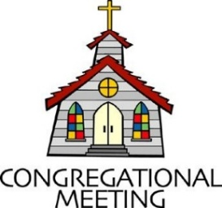
By order of the Session, in compliance with the by-laws, the Congregation of the First Presbyterian Church of Maple Plain, Minnesota, is called to meet in an Annual Meeting on Sunday, February 1, 2025, immediately following worship, in the sanctuary of the church, at 558 County Road 110, Maple Plain, Minnesota.

The meeting is called for the purpose of hearing reports from the various groups within the church and to conduct such other business as may properly come before the annual meeting.

FPC Family,
I want to say a very sincere thank you to everyone at FPC for all the cards, gifts and well-wishes as Jim and I have relocated to North Dakota. Over the last 20 years, we have been blessed to be part of this church family, and I am grateful to you all. You have been a significant part of my faith journey and also that of Robbie and Garrett as they grew and were confirmed at FPC. We will be back to visit, and if anyone finds themselves in the Fargo area, please let me know!
Blessings,
Julie Lokken

NO January Men’s Breakfast
Dave Tillman

Men’s Breakfast will not be held in January, because the Men’s Retreat will be two weeks later. Besides, I will be out of town. So, the next Men’s Breakfast will be February 14th. Be thinking of what we might do to make it special for our significant others’.
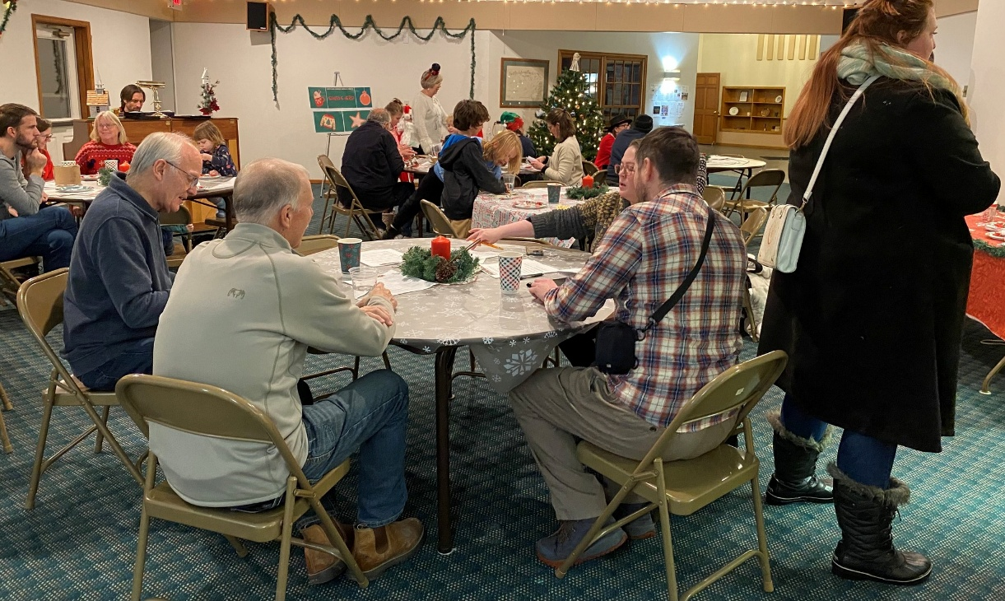
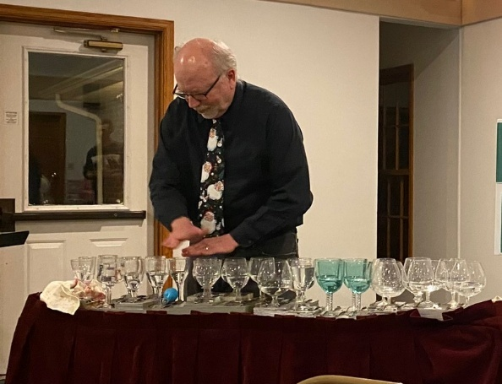
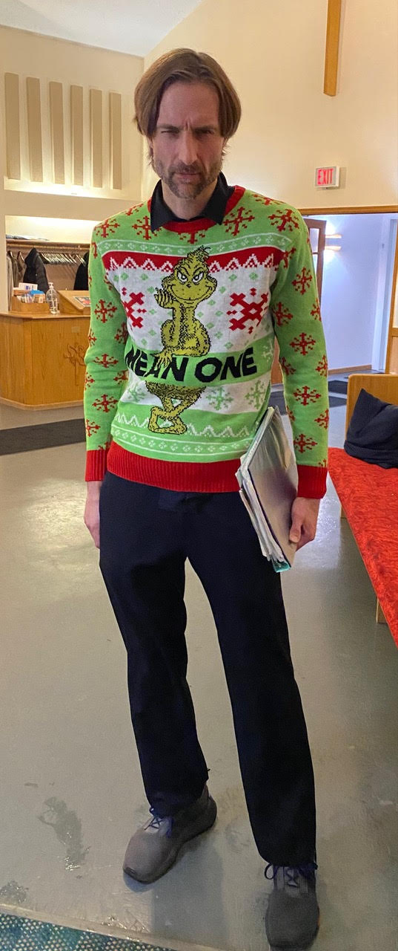
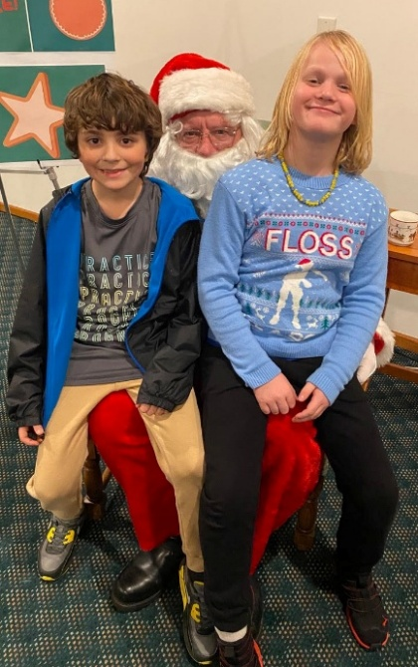
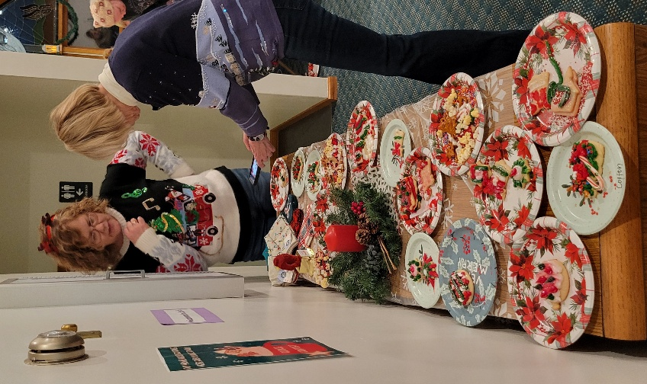
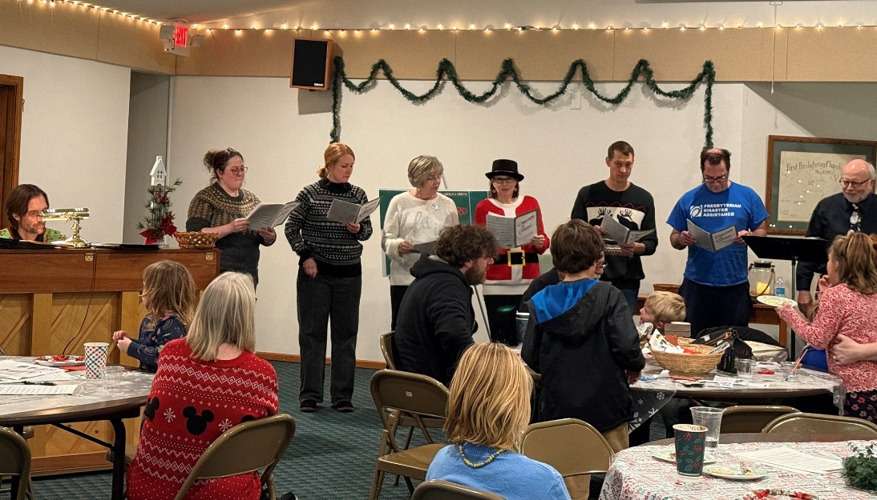


Cookies, Carols & Crafts: December 10th
Dave Tillman
Our annual Cookies, Carols & Crafts night was an energetic time of Christmas cheer. The cookie decoration contest was very creative. The music included Jonathan’s piano, Dave’s glass harp, the choir’s voices, and everyone else singing along!

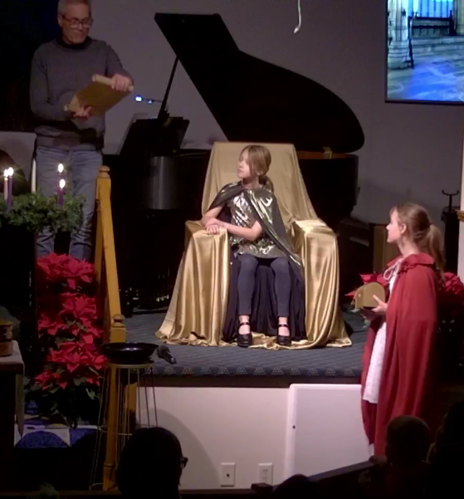
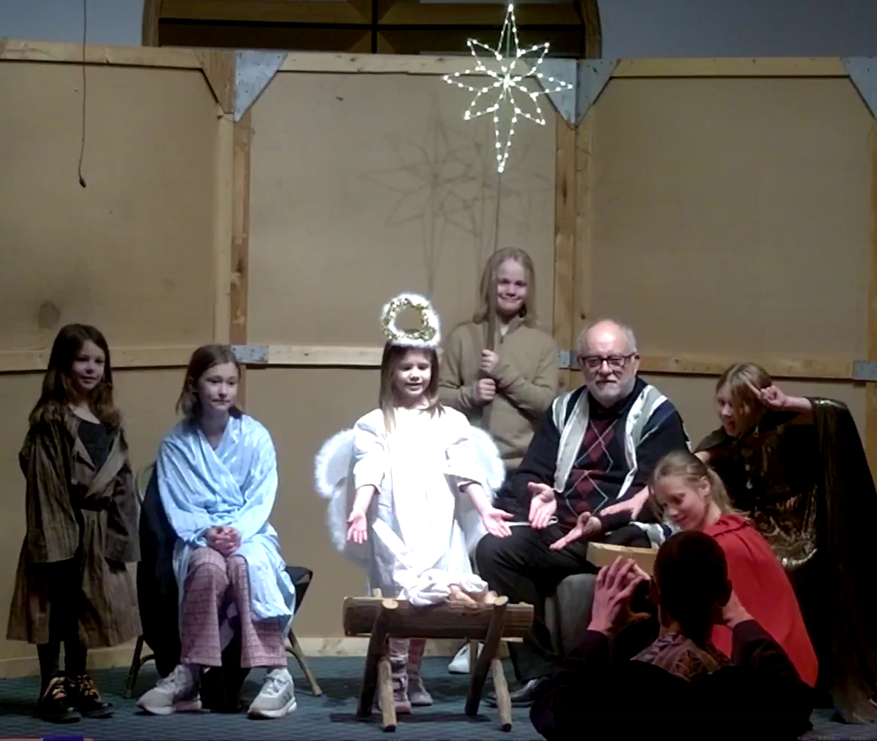
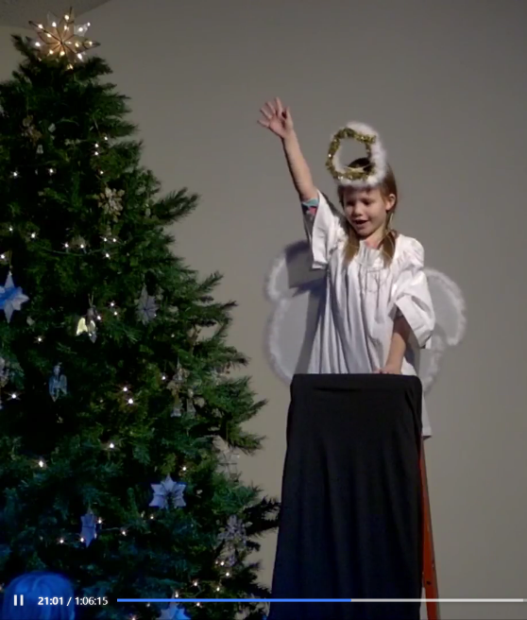
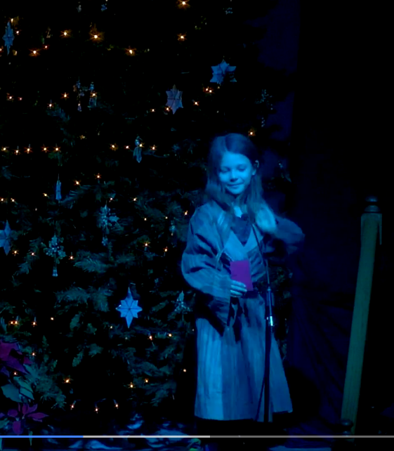

Christmas Eve Service: Help Tell the Story
Dave Tillman
The Christmas Eve service headlined an “impromptu” pageant that pulled some people from the audience to fill some of the roles. There wasn’t much rehearsal, but it turned out very well. The night started with Dave Tillman playing the glass harp and ended with communion and singing Silent Night in a candle-lit circle. Over sixty people attended this service; it was an eventful night!

January 2025

Worship Assistants
 | Coffee & Fellowship |  |  | Liturgist
04 | Betsy Wolfe |  | 04
11 | Sue & Jeff Potter |  | 11
18 | Kyle Shmidt & Sue Prok |  | 18
25 | Heather Baker |  | 25
 | Usher/Greeters |  |  | Sunday School
04 | Helen Chun |  | 04 | Sue Potter
11 |  |  | 11 | Blair Voigt
18 |  |  | 18
25 |  |  | 25 | ~ NO SUNDAY SCHOOL ~

Communion: January 11th
Communion Prep:
Communion Servers:

If you can help on Sundays, find the sign-up sheets in the fellowship hall.

BIRTHDAYS
02 | Harley Kukuk |  | 19 | Bark Kusske
11 | Clyde Bonnema |  | 24 | Adam Kusske
11 | Betsy Wolfe |  | 29 | Dave Tillman
 |  |  | 31 | Natalie Voigt
ANNIVERSARIES
05 | Rev. Dan & Blair Voigt

ONE-YEAR ANNIVERSARY OF DEATH
01/16/17 | Lee Gualtieri
01/18/22 | Ernie Walters

The latest calendar is available at:
CatchOurSpirit.org/calendar

January 2026
Sunday | Monday | Tuesday | Wednesday | Thursday | Friday | Saturday
28  9:30am Worship  10:30am Fellowship  10:50am Christian Ed  3:00pm - 9:00pm Girl Scouts | 29  11:00am - 7:00pm Children's Music Academy | 30  10:00am Holy Yoga, in-person & streaming on Zoom | 31 | 1 | 2 | 3
4  9:30am Worship  10:30am Fellowship  10:50am Christian Ed  3:00pm - 9:00pm Girl Scouts | 5  11:00am - 7:00pm Children's Music Academy | 6  10:00am Holy Yoga, in-person & streaming on Zoom | 7  6:30pm Contemplative Worship Service  7:15pm Choir Practice | 8  2:00pm Deacons Meeting  6:30pm - 8:00pm Girl Scout Leader Meetings | 9 | 10  8:00am Men's Breakfast CANCELLED
11  9:30am Worship  10:30am Fellowship  10:50am Christian Ed  3:00pm - 9:00pm Girl Scouts | 12  11:00am - 7:00pm Children's Music Academy | 13  10:00am Holy Yoga, in-person & streaming on Zoom | 14  9:00am - 3:00pm West Village Homeschool Co-op  7:00pm Choir Practice | 15  9:00am - 3:00pm West Village Homeschool Co-op | 16 | 17
18  Maple Leaf Articles Due  9:30am Worship  10:30am Fellowship  10:50am Christian Ed  3:00pm - 9:00pm Girl Scouts | 19  11:00am - 7:00pm Children's Music Academy | 20  10:00am Holy Yoga, in-person & streaming on Zoom  6:00pm Session Meeting | 21  9:00am - 3:00pm West Village Homeschool Co-op  7:00pm Choir Practice | 22  9:00am - 3:00pm West Village Homeschool Co-op | 23  Men's Retreat | 24  Men's Retreat
25  Men's Retreat  9:30am Worship  10:30am Fellowship  10:50am Christian Ed  3:00pm - 9:00pm Girl Scouts | 26  11:00am - 7:00pm Children's Music Academy | 27  10:00am Holy Yoga, in-person & streaming on Zoom | 28  9:00am - 3:00pm West Village Homeschool Co-op  7:00pm Choir Practice | 29  9:00am - 3:00pm West Village Homeschool Co-op | 30 | 31

The latest calendar is available at:
CatchOurSpirit.org/calendar


First Presbyterian Church
558 County Road 110
Maple Plain, MN 55359
Address correction requested.

January 2026



First Presbyterian Church of Maple Plain 763-479-2158
Office Hours: Thursdays 11am – 4pm
Fridays 11am – 4pm

Pastor Rev. Dan Voigt pastor@CatchOurSpirit.org
Administrative Assistant Emily Roering office@CatchOurSpirit.org
Choir Director David Tillman ChoirDirector@CatchOurSpirit.org
Clerk of Session Mark Prok markprok59@outlook.com
Deacons Chair Sue Prok mprok@frontiernet.net
Maple Leaf Editor Dave Tillman MapleLeaf@CatchOurSpirit.org

Website:
www.CatchOurSpirit.org

